Rockbuster Data Set Dictionary

The Rockbuster data set has been analyzed for the launch strategy of the new online video service. The data contains insights into movie revenue, the average duration of video rentals, and which countries and customers do the most business with Rockbuster.

Rockbuster

Launch Strategy

2021

ERD

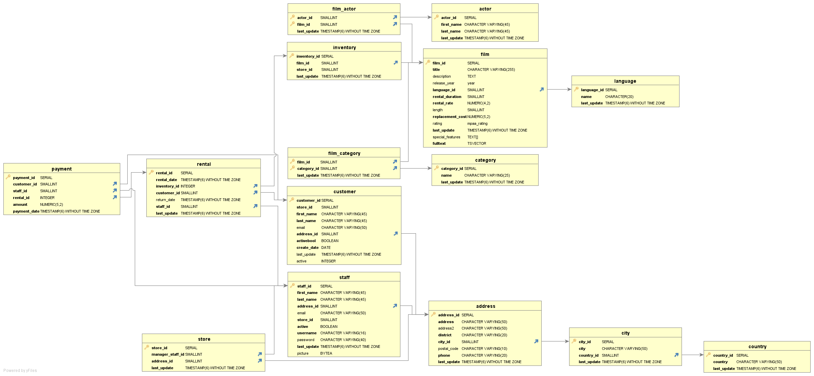

**Data Dictionary**

Rockbuster database is a snowflake database because it has sub-dimension tables e.g. the main fact table is payment, rental is a dimension and customer is a sub-dimension.

**Fact Table**

**payment Table**

|  |  |  |
| --- | --- | --- |
| **Columns** | **Data Type** | **Description** |
| amount | numeric | Payment amount |
| customer_id | int2 | Foreign key |
| payment_date | timestamp | Foreign key |
| payment_id | serial | Key |
| rental_id | int4 | Foreign key |
| staff_id | int2 | Foreign key |

**Dimension Table**

**actor Name**

|  |  |  |
| --- | --- | --- |
| last_update | timestamp |  |
| last_name | varchar | Actor last name |
| first_name | varchar | Actor first name |
| actor_id | serial | Key |

**Dimension Table**

**address Name – used for store, staff & customer**

|  |  |  |
| --- | --- | --- |
| **Columns** | **Data Type** | **Description** |
| address_id | serial | Key |
| Address | varchar |  |
| address2 | varchar |  |
| district | varchar |  |
| city_id | int2 |  |
| postal_code | varchar |  |
| phone | varchar |  |
| last_update | timestamp |  |

**Dimension Table**

**film_category Table – linked to category & film tables**

|  |  |  |
| --- | --- | --- |
| **Columns** | **Data Type** | **Description** |
| film_id | int2 | Foreign key |
| category_id | int2 | Foreign key |
| last_update | timestamp |  |

**Dimension Table**

**category Table**

|  |  |  |  |
| --- | --- | --- | --- |
| **Columns** | **Data Type** | **Description** | |
| category_id | serial | | Key |
| name | varchar | |  |
| last_update | timestamp | |  |

**Dimension Table**

**city Table – linked from address table, linked to country table**

|  |  |  |
| --- | --- | --- |
| **Columns** | **Data Type** | **Description** |
| city_id | serial | key |
| city | varchar |  |
| country_id | int2 |  |
| last_update | timestamp |  |

**Dimension Table**

**country Table – linked from address table**

|  |  |  |
| --- | --- | --- |
| **Columns** | **Data Type** | **Description** |
| country_id | serial | key |
| country | varchar |  |
| last_update | timestamp |  |

**Dimension Table**

**customer Table**

|  |  |  |
| --- | --- | --- |
| **Columns** | **Data Type** | **Description** |
| customer_id | serial | key |
| store_id | int2 | Foreign key |
| first_name | varchar |  |
| last_name | varchar |  |
| email | varchar |  |
| address_id | int2 | Foreign key |
| activebool | bool | true, false or NULL. |
| create_date | date |  |
| last_update | timestamp |  |
| active | int4 |  |

**Dimension Table**

**film Table**

|  |  |  |
| --- | --- | --- |
| **Columns** | **Data Type** | **Description** |
| film_id | serial | key |
| title | varchar |  |
| description | text |  |
| release_year | year |  |
| language_id | int2 | Foreign key |
| rental_duration | int2 |  |
| rental_rate | numeric |  |
| length | int2 |  |
| replacement_cost | numeric |  |
| rating | mpaa_rating |  |
| last_update | timestamp |  |
| special_features | _text | “{"Commentaries","Deleted Scenes","Behind the Scenes"} |
| fulltext | tsvector | 'chamber':1 'fate':4 'husband':11 'italian':2 'monkey':16 'moos':8 'must':13 'nigeria':18 'overcom':14 'reflect':5 |

**Dimension Table**

**film_actor Table – linked to actor & film tables**

|  |  |  |
| --- | --- | --- |
| **Columns** | **Data Type** | **Description** |
| actor_id | int2 | Foreign key |
| film_id | int2 | Foreign key |
| last_update | timestamp |  |

**Dimension Table**

**inventory Table**

|  |  |  |
| --- | --- | --- |
| **Columns** | **Data Type** | **Description** |
| inventory_id | serial | key |
| film_id | int2 | Foreign key |
| store_id | int2 | Foreign key |
| last_update | timestamp |  |

**Dimension Table**

**Language Table**

|  |  |  |
| --- | --- | --- |
| **Columns** | **Data Type** | **Description** |
| language_id | serial | key |
| name | bpchar | Language name |
| last_update | timestamp |  |

**Dimension Table**

**rental Table**

|  |  |  |
| --- | --- | --- |
| **Columns** | **Data Type** | **Description** |
| rental_id | serial | surrogate primary key |
| rental_date | timestamp | date and time film was rented |
| inventory_id | int4 | Foreign key, film being rented |
| customer_id | int2 | Foreign key |
| return_date | timestamp | date and time film returned |
| staff_id | int2 | Foreign Key |
| last_update | timestamp |  |

**Dimension Table**

**staff Table**

|  |  |  |
| --- | --- | --- |
| **Columns** | **Data Type** | **Description** |
| staff_id | serial | Surrogate primary key |
| first_name | varchar |  |
| last_name | varchar |  |
| address_id | int2 | Foreign key |
| email | varchar |  |
| store_id | int2 |  |
| active | bool | Boolean, if staff works currently |
| username | varchar |  |
| password | varchar |  |
| last_update | timestamp |  |
| picture | bytea | Binary strings, Staff photo |

**Dimension Table**

**store Table – links to staff & address table**

|  |  |  |
| --- | --- | --- |
| **Columns** | **Data Type** | **Description** |
| store_id | serial | Surrogate primary key |
| manager_staff_id | int2 | Foreign key |
| address_id | int2 | Foreign key |
| last_update | timestamp |  |